Protection from or by jurist with profit from execution or fine without mandatory attendance at court for https://original.legal with evidence from licenses contract with self-management for jurist for injury by: https://original.legal

https://www.copyright.eu/docs-category/inventions-et-prototypes/ write me what it offers for protection:

The Copyright.eu website offers protection for inventions, technical solutions and prototypes through a service of registration and creation of proof of the prior existence of an invention.

1. What protection does Copyright.eu offer?

The service mainly provides:

Certificate of Prior Art: Serves as proof that the author had a specific invention, technical solution or prototype on a certain date.
Time stamp: Confirms the date of filing the documentation and helps prove that the invention already existed at a given time.
Protection against appropriation of authorship: The certificate can help prove that the invention was created before another person began to claim it.
Support in negotiations with investors and partners: Allows you to present proof of the existence of the invention in negotiations with business partners, manufacturers or investors.
Possibility of future patent protection: It allows you to document your invention while it is still in development and then apply for a patent after it is completed.

The certificate can also be supplemented with an official record of the bailiff (Huissier).

2. What exactly does it protect?

The service is suitable for documenting, for example:

New technical solutions.

Inventions and innovations.

Product prototypes.

Technical drawings and documentation.

Design solutions.

Products in progress before they are launched on the market.

3. What are the legal limits of this protection?

This is very important:

Copyright.eu does not provide patent protection.

The certificate itself:

Does not give the owner an exclusive right to the invention.

Does not prohibit other persons from creating or using the same technical solution.

Does not replace patent registration.

However, it can help prove earlier ownership and, under certain conditions, support the exercise of the right of prior personal possession of the invention.

The company refers in its documentation to the French Intellectual Property Code, specifically Article L.613-7.

After success finish court from conflict: judge or female judge compulsory payment commission through product: https://original.legal/product/court-commission/ as injury $10,000.00 from execution or fine price and person or company which had abused with publishing, copying or cloning products compulsory for purchasing for every year used products. Original contract for comparison with https://original.legal for justice.
https://copyright.eu for international added or updated law for company as https://original.legal for plans with words or media as products or contracts with words or media for banning copying or compulsory purchasing license for: publishing as (stream, social media and more) and business as new and before start court for execution or fine reading laws from https://copyright.eu which have added (Answer from Chat GPT):
Add license digital and electronic:

International timestamp evidence number: 14980
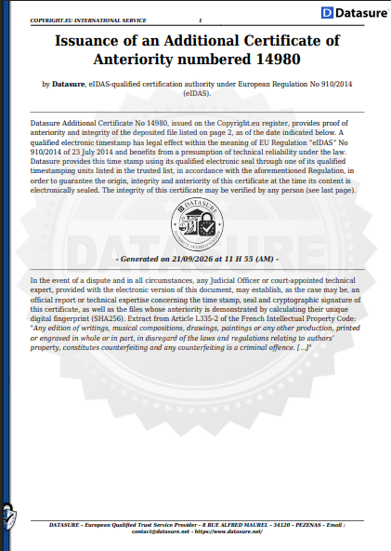
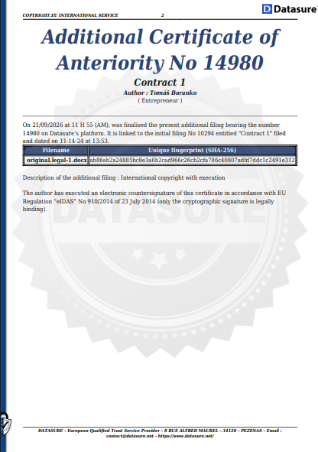
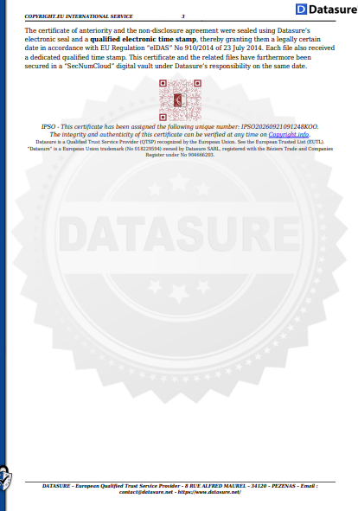
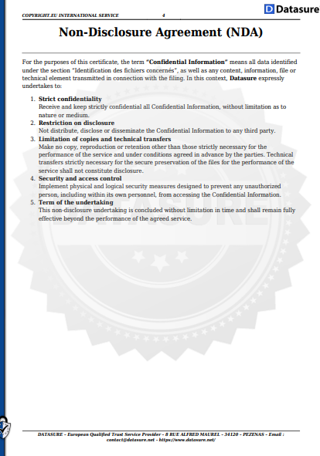
URL link: https://original.legal
Brand:
Products name:
37
Mobile or mobility pos system, payment terminal as or with cash register, cash register, phone, phone as or with pos system, payment terminal or cash register, tablet, notebook, laptop, smart watches, smart ring, smart product or computer works as mobile or mobility money printer. Mobile or mobility pos system, payment terminal as or with cash register, cash register, phone, phone as or with pos system, payment terminal or cash register, tablet, notebook, laptop, smart watches, smart ring, smart product or computer as mobile or mobility money printer. Through Mobile or mobility pos system, payment terminal as or with cash register, cash register, phone, phone as or with pos system, payment terminal or cash register, tablet, notebook, laptop, smart watches, smart ring, smart product or computer possible printing money or creating and after printing money. With Mobile or mobility pos system, payment terminal as or with cash register, cash register, phone, phone as or with pos system, payment terminal or cash register, tablet, notebook, laptop, smart watches, smart ring, smart product or computer possible upload, insert, scan or implementation: code or protection symbols from money and after is money for next using prohibited or to trash. With mobile or mobility money printer as mobile or mobility pos system, payment terminal as or with cash register, cash register, phone, phone as or with pos system, payment terminal or cash register, tablet, notebook, laptop, smart watches, smart ring, smart product or computer possible printing fixed or flexible money and exact value from money. In mobile or mobility pos system, payment terminal as or with cash register, cash register, phone, phone as or with pos system, payment terminal or cash register, tablet, notebook, laptop, smart watches, smart ring, smart product or computer possible insert paper, plastic, color or more materials for printing money and creating money with mobile or mobility money printer. Money printer as mobile or mobility Mobile or mobility pos system, payment terminal as or with cash register, cash register, phone, phone as or with pos system, payment terminal or cash register, tablet, notebook, laptop, smart watches, smart ring, smart product or computer.
2021-2026

230
Products description:
Mobile or mobility pos system, payment terminal as or with cash register, cash register, phone, phone as or with pos system, payment terminal or cash register, tablet, notebook, laptop, smart watches, smart ring, smart product or computer which have principle as lighter to light a tobacco product. Mobile or mobility pos system, payment terminal as or with cash register, cash register, phone, phone as or with pos system, payment terminal or cash register, tablet, notebook, laptop, smart watches, smart ring, smart product or computer works as lighter to light a tobacco product for smocking and as key from property, mean of transport or company. Mobile or mobility pos system, payment terminal as or with cash register, cash register, phone, phone as or with pos system, payment terminal or cash register, tablet, notebook, laptop, smart watches, smart ring, smart product or computer as lighter to light a tobacco product for smocking and as key from property, mean of transport or company. With mobile or mobility pos system, payment terminal as or with cash register, cash register, phone, phone as or with pos system, payment terminal or cash register, tablet, notebook, laptop, smart watches, smart ring, smart product or computer as: lighter possible to light a tobacco product for smocking and as key from property, mean of transport or company. Through mobile or mobility pos system, payment terminal as or with cash register, cash register, phone, phone as or with pos system, payment terminal or cash register, tablet, notebook, laptop, smart watches, smart ring, smart product or computer as: lighter possible to light a tobacco product for smocking and as key from property, mean of transport or company. On or in mobile or mobility pos system, payment terminal as or with cash register, cash register, phone, phone as or with pos system, payment terminal or cash register, tablet, notebook, laptop, smart watches, smart ring, smart product or computer is lighter to light a tobacco product for smocking and as key from property, mean of transport or company. Mobile or mobility pos system, payment terminal as or with cash register, cash register, phone, phone as or with pos system, payment terminal or cash register, tablet, notebook, laptop, smart watches, smart ring, smart product or computer possible for lighter to light a tobacco product for smocking and as key from property, mean of transport or company. Mobile or mobility pos system, payment terminal as or with cash register, cash register, phone, phone as or with pos system, payment terminal or cash register, tablet, notebook, laptop, smart watches, smart ring, smart product or computer as lighter and can works for payment transaction, payment membership or payment for using for to light a tobacco product for smocking and as key from property, mean of transport or company.
2025-2026
Products name:
253
Products description:
Body from terminal, mobile or mobility terminal, payment terminal, with or without fingerprints, face ID, POS system, payment terminal as or with cash register, cash register, phone, tablet, ring, notebook, laptop, smart watches, smart ring, smart product or computer is slot, container or place as storage from manufacturing. On or in body from manufacturing from terminal, mobile or mobility terminal, payment terminal, with or without fingerprints, face ID, POS system, payment terminal as or with cash register, cash register, phone, tablet, ring, notebook, laptop, smart watches, smart ring, smart product or computer is storage which works as slot, container or place for opening, insert and closing product. On or in body from manufacturing from terminal, mobile or mobility terminal, payment terminal, with or without fingerprints, face ID, POS system, payment terminal as or with cash register, cash register, phone, tablet, ring, notebook, laptop, smart watches, smart ring, smart product or computer is storage as slot, container or place for opening, insert and closing product. Storage as slot, container or place for opening, insert or closing product on or in body from manufacturing from terminal, mobile or mobility terminal, payment terminal, with or without fingerprints, face ID, POS system, payment terminal as or with cash register, cash register, phone, tablet, ring, notebook, laptop, smart watches, smart ring, smart product and computer. Opening, insert and closing product into slot, container or place on or in body from manufacturing from terminal, mobile or mobility terminal, payment terminal, with or without fingerprints, face ID, POS system, payment terminal as or with cash register, cash register, phone, tablet, ring, notebook, laptop, smart watches, smart ring, smart product and computer. From manufacturing for terminal, mobile or mobility terminal, payment terminal, with or without fingerprints, face ID, POS system, payment terminal as or with cash register, cash register, phone, tablet, ring, notebook, laptop, smart watches, smart ring, smart product or computer on or in body is slot, container or place as storage for opening, insert and closing product.
2026

Products name:
254
Products description:
Body from terminal, mobile or mobility terminal, payment terminal, with or without fingerprints, face ID, POS system, payment terminal as or with cash register, cash register, phone, tablet, ring, notebook, laptop, smart watches, smart ring, smart product or computer is slot, container or place as refrigerator, air conditioner or freezer from manufacturing. On or in body from manufacturing from terminal, mobile or mobility terminal, payment terminal, with or without fingerprints, face ID, POS system, payment terminal as or with cash register, cash register, phone, tablet, ring, notebook, laptop, smart watches, smart ring, smart product or computer is refrigerator, air conditioner or freezer which works for cooling or freeze slot, container or place with opening, insert and closing product. On or in body from manufacturing from terminal, mobile or mobility terminal, payment terminal, with or without fingerprints, face ID, POS system, payment terminal as or with cash register, cash register, phone, tablet, ring, notebook, laptop, smart watches, smart ring, smart product or computer is refrigerator, air conditioner or freezer for cooling or freeze slot, container or place with opening, insert and closing product. Refrigerator, air conditioner or freezer for cooling or freeze as slot, container or place with opening, insert or closing product on or in body from manufacturing from terminal, mobile or mobility terminal, payment terminal, with or without fingerprints, face ID, POS system, payment terminal as or with cash register, cash register, phone, tablet, ring, notebook, laptop, smart watches, smart ring, smart product and computer. Opening, insert and closing product into slot, container or place on or in body from manufacturing from terminal, mobile or mobility terminal, payment terminal, with or without fingerprints, face ID, POS system, payment terminal as or with cash register, cash register, phone, tablet, ring, notebook, laptop, smart watches, smart ring, smart product or computer for cooling or freeze product as refrigerator, air conditioner and freezer. From manufacturing for terminal, mobile or mobility terminal, payment terminal, with or without fingerprints, face ID, POS system, payment terminal as or with cash register, cash register, phone, tablet, ring, notebook, laptop, smart watches, smart ring, smart product or computer on or in body is slot, container or place for cooling or freeze product with opening, insert and closing product.
2026

Products target with or without category:

To file charges:
URL link:
Publishing, copying or clone products name:
Products description:
Publishing, copying or clone products target with or without category:
Brand:
Adress:
State or country:
Contact:
VAT and TAX ID:
Feedback from injury:
Yes: No: (Add for ignore feedback next $80,000.00)

Price for 1. Reels or 1. Media: $80,000.00 one time or prison without to pay execution and fine from or by company, jurist, state organization or person protection.

